**Excel Assignment - 6**

1. **What are the various elements of the Excel interface? Describe how**

**they're used.**

Ans – elements of the Excel interdace –

**1.Ribbon** – the Ribbon interface contains the commands that are available for use in Excel. This has multiple tabs including the File, Home, Insert, Page Layout, Formulas, Data, Review, View, Add-ins, and Help tabs. There are tabs that will appear when necessary; for example, the Format tab appears when you click an inserted shape.

The tabs are then subdivided in groups based on the usage of the commands. For example, in the Home tab, the commands are grouped in Clipboard, Font, Alignment, Number, Styles, Cells, and Editing.

### 2.Name Box -The Name Box is an input box which normally displays the name or location of the active cell on the worksheet. This is also used to directly create a named range. When you open a blank workbook, the selected cell is A1, by default.

### 3.Formula Quick menu -The Formula Quick Menu beside the Name box is a shortcut when you want to insert a function. If you click the fx option, the Insert Function will pop-up to let you choose which Excel function would you like to use.

**4.Formula A bar -** The Formula Bar is found just beside the Formula Quick Menu. This allows you to enter or edit data, formula or a function that will appear in the selected cell whose name or location appears in the Name Box.

**5.Status Bar -** The Status Bar in the bottom-left corner of the Excel window displays various information about the current mode of the workbook.

**6.Worksheet View Option** - The Worksheet View Options lets you choose which of the 3 worksheet views you want (Normal, Page Layout, or Page Break Preview). By default, the worksheet view is set to Normal.

**7. Zoom Slider Controler -** The Zoom Slider Control helps you zoom in and zoom out the worksheet.

**8. Zoom percentage indicator** - The Zoom Percentage Indicator displays the zoom percentage just beside the Zoom Slider Control. By default, it is set to 100%.

1. **Write down the various applications of Excel in the industry**.

ANS - Businesses use Excel to store, visualize, and analyze data. The multiple uses of [Excel in business](https://amzn.to/3X6dRFA) make it one of the main reasons industry use Excel every day. Data entry

1. Data management
2. Accounting
3. Financial analysis
4. Charting and graphing
5. Programming
6. Time management
7. Task management
8. Financial modeling
9. Customer relationship management.

**3.On the ribbon, make a new tab. Add some different groups, insert commands in the groups and name them according to their commands 1.added. Copy and paste the screenshot of the steps you followed.**

Ans –

1. **How to customize ribbon in Excel -**Most customizations to the Excel ribbon are done in the Customize the Ribbon window, which is part of Excel Options. So, to start customizing the ribbon, do one of the following:

* Go to File > Options > Customize Ribbon.
* Right-click on the ribbon and select **Customize the Ribbon…** from the context menu:

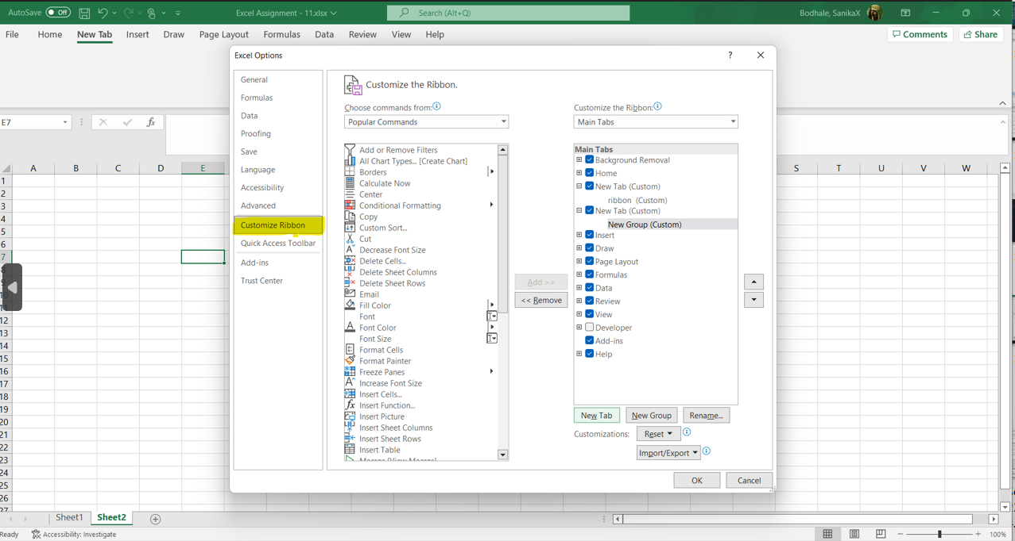

2.How to create a new tab for the ribbon

To make your favorite commands easily accessible, you can add your own tab to the Excel ribbon. Here's how:

1.In the *Customize the Ribbon* window, under the list of tabs, click the **New Tab** button.

2.This adds a custom tab with a custom group because commands can only be added to custom groups.

3. rename the file and click on **OK**.

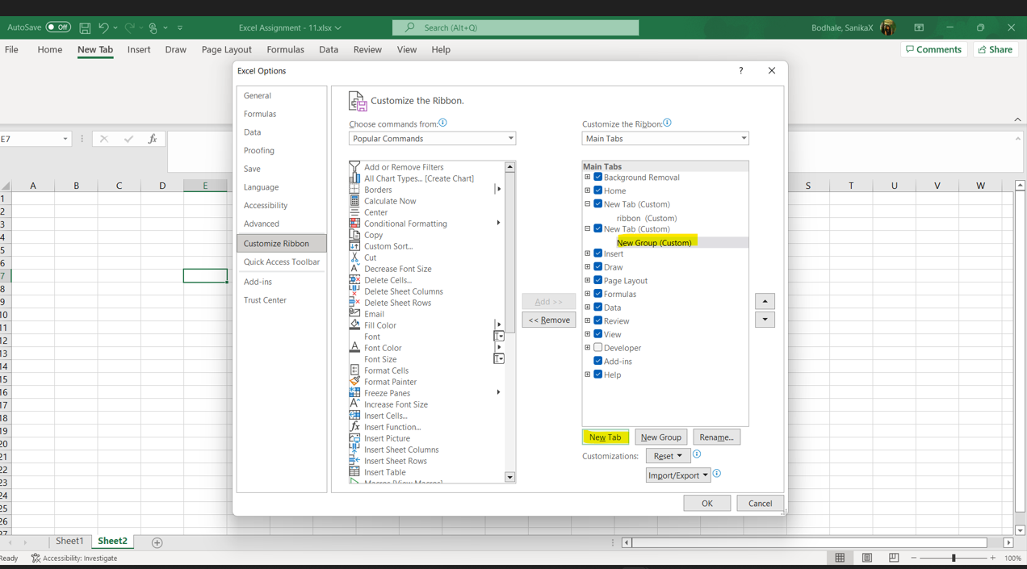

3.**How to add a custom group to a ribbon tab**

1. In the list under *Customize the Ribbon*, select the target custom group.
2. In the *Choose commands from* drop-down list on the left, select the list from which you want to add commands, for example, *Popular Commands* or *Commands Not in the Ribbon*.
3. In the list of commands on the left, click the command you want to add.
4. Click the **Add** button.
5. Click *OK* to save the changes.

As an example, we are adding add the *Subscript* and *Superscript* buttons to the custom tab that we created:

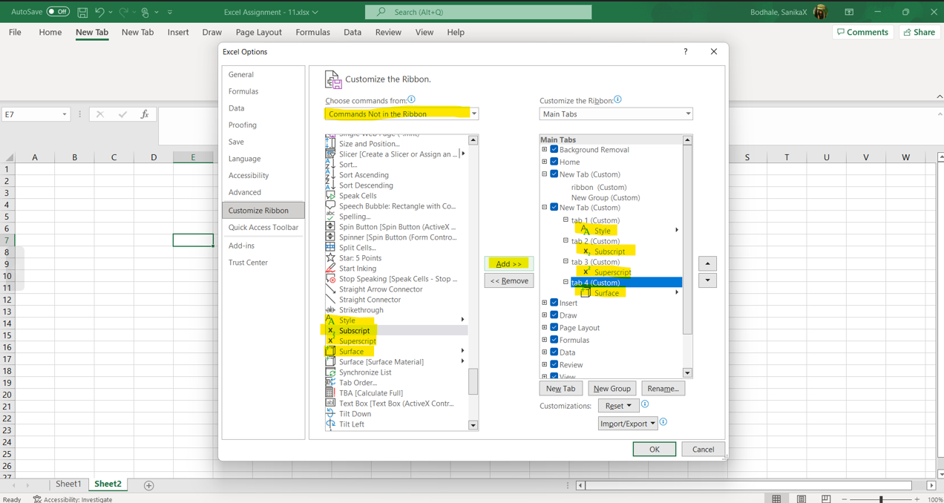

**4.Make a list of different shortcut keys that are only connected to formatting with their functions**.

Ans –

**Short-cut Keys** and their **Descriptions**

**Alt + F:**File menu options in current program.

**Alt + E:**Edit options in current program

**F1:**Universal Help in almost every Windows program.

**Ctrl + A:** Select all text.

**Ctrl + X:**Cut

**Shift + Del:**Cut selected item.

**Ctrl + C:**Copy selected item.

**Ctrl + Ins:**Copy selected item.

**Ctrl + V:**Paste selected item.

**Shift + Ins:**Paste.

**Home:**Goes to beginning of current line.

**Ctrl + Home:**Goes to beginning of document.

**End:**Goes to end of current line.

**Ctrl + End:**Goes to end of document

**Shift + Home:**Highlights from current position to beginning of line.

**Shift + End:**Highlights from current position to end of line.

**Ctrl + Left arrow:**Moves one word to the left at a time.

**Ctrl + Right arrow:**Moves one word to the right at a time.

**5.what distinguishes excel from other analytical tools**

Ans – Microsoft Excel is a spreadsheet application used for calculations, statistical operations, data analysis, and reporting. [Tableau](https://www.simplilearn.com/learn-tableau-tips-to-start-article) is a business intelligence and data visualization tool to get insights from data, find hidden trends, and make business decisions.

Tableau and [Excel](https://www.simplilearn.com/tutorials/excel-tutorial/excel-dashboard) are two highly effective tools for the creation, development, storage, and analysis of your data. Companies use them both, but they have distinct features and functionalities. In this Excel vs. Tableau article, we will discuss some key differences between them.

Tableau and [Excel](https://www.simplilearn.com/tutorials/excel-tutorial/excel-dashboard) are two highly effective tools for the creation, development, storage, and analysis of your data. Companies use them both, but they have distinct features and functionalities. In this Excel vs. Tableau article, we will discuss some key differences between them.

## **What is Excel?**

Microsoft Excel is a spreadsheet application that stores data in the form of rows and columns. We usually store the information in cells. You can add tables, charts, graphics, and various visualizations to make it more presentable, as per your requirement.

### Advantages of Excel

* Microsoft Excel can analyze large amounts of data to discover trends and patterns that will help in decision making.
* Excel can perform most of the mathematical and logical functions with ease.

**What Is Tableau?**

Tableau is a Business Intelligence software that allows anyone to connect, visualize, and create interactive and shareable dashboards with just a few clicks. Tableau visualizes data right from the start, so that you can see the significance almost immediately. It differentiates correlations using color, size, labels, and shapes, giving you context as you drill down and explore on a granular level.

### Advantages of Tableau

* Tableau Dashboard comprises an outstanding reporting feature that enables you to customize the dashboard. This is applicable specifically for a mobile phone or laptop device.
* Tableau users can include Python or R scripts for complex table calculations.
* Tableau can handle a large volume of data with ease.

**6. create a table and add custom header and footer in excel**

Ans - add headers or footers at the top or bottom of a printed worksheet in Excel. For example, you might create a footer that has page numbers, the date, and the name of your file. You can create your own, or use many built-in headers and footers.

Headers and footers are displayed only in **Page Layout** view, **Print Preview**, and on printed pages. You can also use the **Page Setup** dialog box if you want to insert headers or footers for more than one worksheet at a time. For other sheet types, such as chart sheets, or charts, you can insert headers and footers only by using the **Page Setup** dialog box.

1. Click the worksheet where you want to add or change headers or footers.
2. On the Insert tab, in the Text group, click Header & Footer.
3. To add or edit a header or footer, click the left, center, or right header or footer text box at the top or the bottom of the worksheet page (under Header, or above Footer).
4. Click on Header and Footer.

